Day 1: Linux / WSL Lab Report

Name: | Muhammad Kaleem Faryad
Course: | (Add your course name)
Lab Title: | Linux Commands and WSL Practice
Date: | (02/05/2026)

Exercise 1: Directory Structure Creation
Objective
To create a nested directory structure using mkdir and touch, and verify it using tree.

Commands Used
mkdir -p project/src/{rtl,tb,include} project/{docs,scripts,build} touch project/src/rtl/file1.v touch project/src/tb/test1.v touch project/src/include/defs.h tree project

Explanation
- mkdir -p creates directories recursively.
- {} brace expansion creates multiple directories in a single command.
- touch creates empty files at the specified paths.
- tree displays the full directory hierarchy in a visual format.
Output
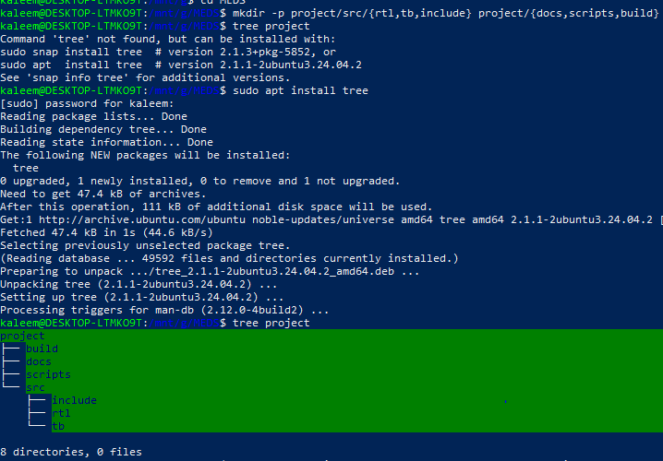

Exercise 2: Download and Analyze File
Objective
To download the RISC-V ISA manual and analyze its properties using Linux utilities.

Commands Used
wget https://riscv.org/wp-content/uploads/2019/12/riscv-spec-20191213.pdf ls -lh riscv-spec-20191213.pdf file riscv-spec-20191213.pdf

Explanation
- wget downloads files from the internet using HTTP/HTTPS/FTP.
- ls -lh lists file details including size in human-readable form and permissions.
- file identifies the type of a file by inspecting its contents.

Output
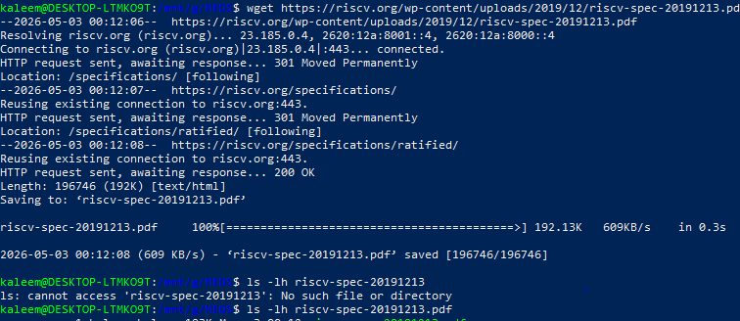

Exercise 3: File Processing and Pipelines
Objective
To generate random data and process it using Linux pipelines and text utilities.

Commands Used
for i in {1..100}; do echo $RANDOM; done > random.txt sort random.txt > sorted.txt uniq -c sorted.txt > counted.txt sort -nr counted.txt | head -10 > top10.txt

Explanation
- $RANDOM is a bash built-in that generates a pseudo-random integer.
- sort arranges lines of text alphabetically or numerically.
- uniq -c filters duplicate lines and prefixes each with its count.
- sort -nr sorts numerically in descending (reverse) order.
- head -10 selects and displays only the top 10 lines.
Output
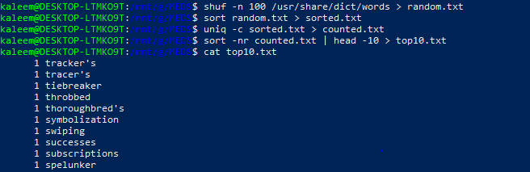

Exercise 4: SSH Setup for GitHub
Objective
To configure SSH key-based authentication with GitHub for secure repository access.

Commands Used
ssh-keygen -t ed25519 -C "your_email@example.com" eval "$(ssh-agent -s)" ssh-add ~/.ssh/id_ed25519 cat ~/.ssh/id_ed25519.pub ssh -T git@github.com

Explanation
- ssh-keygen generates an Ed25519 SSH key pair (public + private).
- ssh-agent is a background process that holds private keys in memory.
- ssh-add loads the private key into the running SSH agent.
- cat prints the public key so it can be copied to GitHub settings.
- ssh -T tests the SSH connection to GitHub without opening a shell.

Output
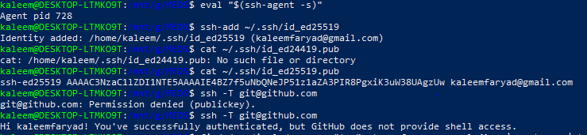

Exercise 6 (Bonus): One-Liner Pipeline
Objective
To find the largest .c files based on line count using a single pipeline command.
Command Used
find /usr/include -name "*.c" -type f -exec wc -l {} + | sort -nr | head -5

Explanation
- find recursively searches for files matching the given name pattern.
- -exec wc -l {} + counts lines in all matched files in one invocation.
- sort -nr sorts results by line count in descending order.
- head -5 limits output to the top 5 results.
Output
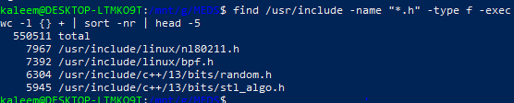

Linux / WSL Lab Report — Muhammad Kaleem Faryad

